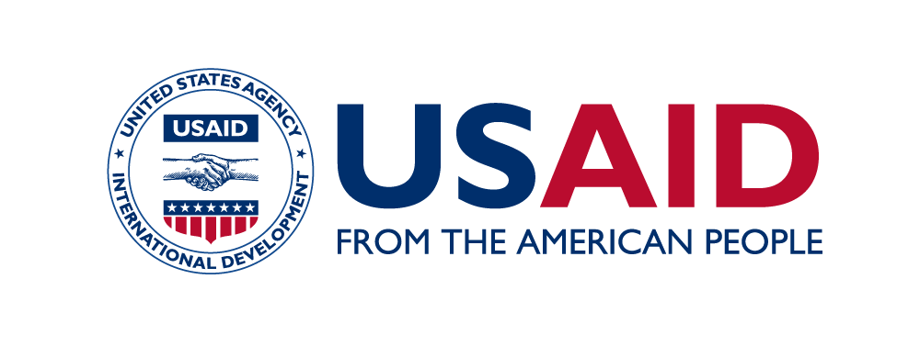
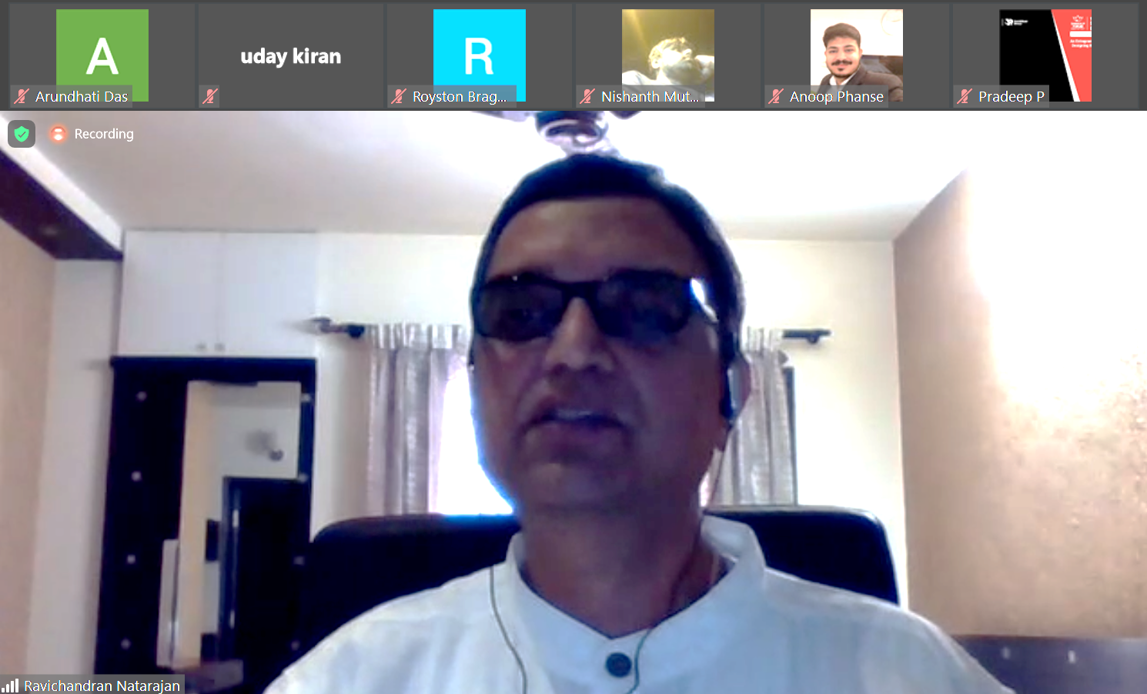
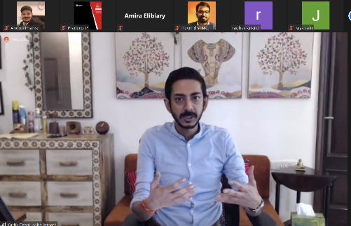
Session Moderator: Mr. Kartik Desai, Executive Director, Asha Impact
Session Panelists: Ms. Avneet Kaur, Int’l Collaborations & Corporate Strategy Head, NSDC | Ms. Dhun Davar, Social Finance & India Head, UBS Optimus Foundation | Mr. Ravi Natarajan, Project Head, Blended Finance Facility, IPE Global Mr. Shantanu Ghosh, CEO, Social Finance India | Mr. Shravan Hardika, Municipal Commissioner, Pimpri Chinchwad
SANKALP GLOBAL SUMMIT 2020
Session: Scaling Blended Finance in India | November 02, 2020
Key Highlights
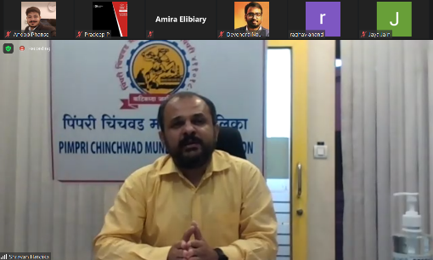
The Blended Finance Facility (BFF), set up under Partnerships for Affordable Healthcare Access and Longevity (PAHAL), participated in the session on Blended Finance at Sankalp Global Summit 2020, on Nov 2nd 2020. This forum is an initiative led by Intellecap, and is one of the world's largest impact enterprise focused platforms. Through its annual summits it brings together entrepreneurs, investors, governments, corporations, media and civil society to drive a paradigm shift in inclusive development approaches.
The BFF leveraged this opportunity to enhance its visibility and build networks within the ecosystem of social enterprises and investors/funders, for fund mobilisation as well as to build its investment pipeline.
The panel, which included three development finance practitioners and two pioneering government leaders, focussed on the following key areas to share their perspectives on scaling blended finance tools in India:
- Opportunities and challenges in the blended finance market, and what potential do investors see in this space.
- Role and perspectives of the government in advancing adoption of innovative financing models to solve key development challenges.
- Market building to pool capital, reduce cost and drive liquidity for start-ups and innovators.
- Models and interventions for public private collaborations to leverage blended finance
Highlights of the discussion:
- Collaboration with governments in U.S. and U.K. markets have transitioned from impact bonds and pooling structures to more nuanced instruments such as income share agreement (in the U.S.).
- Government of India, both at the national and local level, is experimenting with various innovative outcome based financial instruments to solve challenges in the area of skill development, education and health.
- Public sector interventions, in addition to classic impact bond structures, are also leveraging innovative tools such as first loss default guarantee to accelerate scale and impact of their programs (particularly for skilling and education). In doing so, entities such as NSDC and Social Finance India are mobilizing grant budgets of philanthropic donors/CSR divisions.
- Some of the key risks the government sees in innovative financing are that of procurement, quantifying risk premium, assessing impact for pay-for-performance models and legal threats.
- Use of innovative technology, slum rehabilitation, healthcare services and hawker management are key development areas for which local governments can effectively leverage blended finance instruments.
- Need to devise innovative financial instruments/risk sharing models that can attract quality debt capital and raise working capital for social enterprises/innovators, particularly in the healthcare context.

