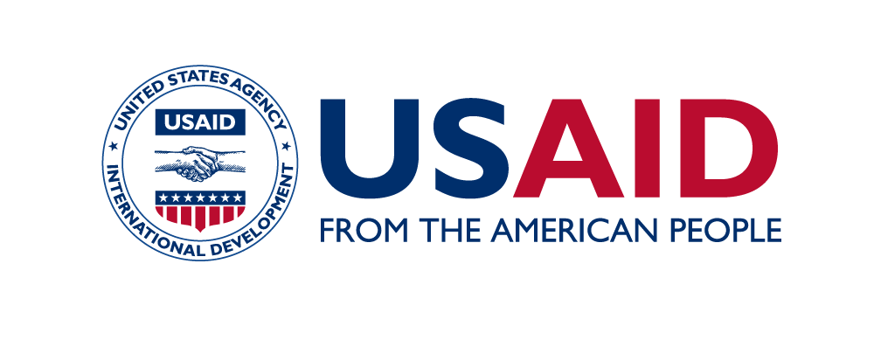
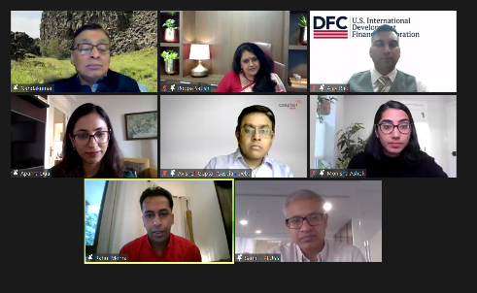
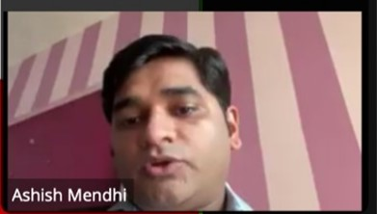
Presenter: Dr. Ashish Mendhi, Project Lead, SAMRIDH
Session Moderator: Dr. Allayla Nandakumar, Executive Director, Professor Brandeis University
Session Panelists: Ms. Roopa Satish, Country Head, Corporate and Investment Bank, IndusInd Bank | Mr. Ajay Rao, Regional Managing Director, Development Finance Corporation | Mr. Avishek Gupta, Investment Director, Caspian | Ms. Aparna Dua, Director, ASHA Trust Session Discussants: Mr. Samit Jain, Managing Director, PLUSS | Ms. Monisha Ashok, Senior Advisor Center for Innovation & Impact, USAID | Mr. Rahul Mehra, Chairman and Founder, AWL India Pvt Ltd

SANKALP GLOBAL SUMMIT 2021
Session: Blended Finance – Supporting India’s COVID-19 recovery and long-term health systems | October 14, 2021
Key Highlights
SAMRIDH Healthcare Blended Financing Facility, supported by USAID, hosted a session on Blended Financing at Sankalp Global Summit 2021. Sankalp is an initiative led by Intellecap and is one of the world's largest impact enterprise focused platforms. Through its annual summits it brings together entrepreneurs, investors, governments, corporations, media, and civil society to drive a paradigm shift in inclusive development approaches.
SAMRIDH leveraged this opportunity to enhance its visibility and build networks within the ecosystem of investors/funders and social enterprises, for fund mobilisation as well as to build a pipeline of market-based health solutions. The session began with a presentation by Mr. Ashish Mendhi - Project Director, SAMRIDH. He gave an overview of the initiative, highlighting its goals and approach. In addition, he showcased SAMRIDH’s recently designed blended financing structures that are supporting the expansion of high impact health solutions in India.
The panellists focussed on the following key areas to share their perspectives on the criticality of blended finance tools in strengthening India’s healthcare system during and post the COVID-19pandemic:
- Challenges of traditional financing models and the role blended finance can play in overcoming these.
- Role of partnership to enable blended finance for healthcare solutions.
- Fundamental shifts in the healthcare ecosystem post the pandemic which have highlighted inefficiencies in the system.
- Key challenges to blended finance and how they can be overcome.
Highlights of the discussion:
- The healthcare sector in India is very complex with different players at different maturity and risk profiles. On the one hand the sector assures stable cash inflows, making it attractive for investors. On the other, the rising innovations in the space, makes predictability of cash flows challenging, limiting commercial investor’ participation in the sector.
- Blended finance plays a critical role in balancing the risk and return on investments in healthcare solutions.
- Partnerships are key to mobilize blended capital for a mixed portfolio of healthcare solutions and leveraging a range of technical expertise to bring about impact at scale. Moreover, the establishment of a governance structure with specific roles and responsibilities from the outset is required for smooth functioning.
- The pandemic has highlighted the need for distributive healthcare, investment across supply chains, and insurance-led healthcare. With the rise in healthcare innovations to tackle the pandemic, there is a misalignment between the funding needs of the health sector and the resources available through traditional financial instruments, such as private equity and venture capital. This is where blended finance will be critical in bridging the gaps and creating linkages to allow for rapid sustainable growth of small enterprises.
- The biggest challenge faced by blended finance is the lack of clarity and recognition in the policy environment of its ability to catalyse investment and facilitate the creation of more resilient health systems.

